How to give read and write permissions using Unix commands. A very simple example is to create a text file with a C program, then use chmod.

Create a file called permission.c
#include <stdio.h> int main()
{
FILE *fp;
fp = fopen("sample.txt", "w"); if (fp == NULL)
{
printf("Cannot open file\n"); return 1;
}
fprintf(fp, "Hello, this is a test file.\n"); fclose(fp);
printf("File created successfully.\n"); return 0;
}

Compile
gcc permission.c -o permission

Run
./permission

Output
File created successfully.

A file called sample.txt is created.

Check the current permissions

ls -l sample.txt

You may see

-rw-r--r-- 1 user user 31 Aug 17 08:20 sample.txt

The owner has: Read + Write Group has: Read
Others have: Read This is permission 644.

Give Read and Write permission to everyone
chmod 666 sample.txt Check ls -l sample.txt You should see
-rw-rw-rw- 1 user user ... sample.txt

Instead of numbers, you can directly give:
chmod u+rw sample.txt chmod o+rw sample.txt chmod a+rw sample.txt

Task of the Day
- Give Read and Write only to the owner
- Give Read and Write to the owner and group
- Only owner can read and write
- Owner read/write, everyone else read-only
- Owner can do everything, others can only read and execute
- Owner and group can read/write
- Only owner can execute
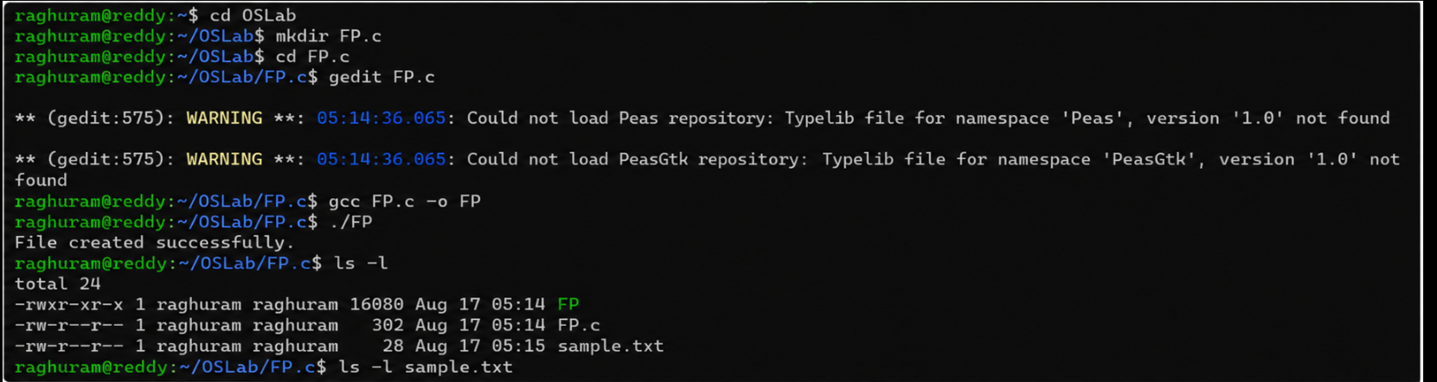
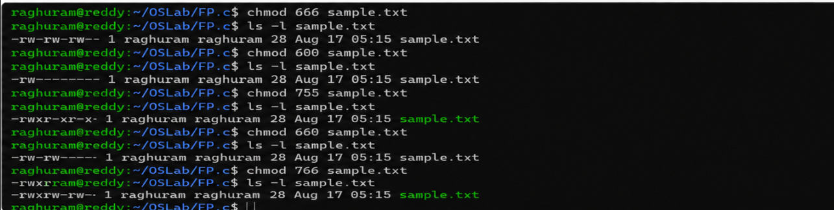
Fill in the permission numbers for the following:
- Owner: read + write; Group: nothing; Others: nothing
→600
- Owner: read + write; Group: read; Others: read →644

- Owner: read + write + execute; Group: read + execute; Others: read + execute → 755
- Owner: read + write; Group: read + write; Others: nothing →660
- Everyone: read only →444

